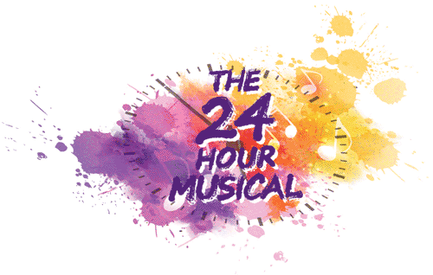 7-8 September 2018
Thank you for signing up to be a part of 24 Hour Musical at Camberley Theatre.
Please complete all parts of this form so the production team can plan in advance.
Name of performer
Contact Email
Contact Mobile Number
Playing Age
Costume Sizes – Men | Hat Neck  Nape of neck to waist Chest  Waist Shoulder to shoulder  Leg Inside Leg  Shoe Height
Costume Sizes – Women | Hat Glove  Nape of neck to waist Chest/Bust  Waist Shoulder to shoulder  Hip Inside Leg  Shoe Height
Singing Skills – please tick | Soprano (high) Mezzo (mid) Alto (low)  Tenor (high) Baritone (mid) Bass (low)  I’m not sure what any of this means, but I’ll give it a go!
Dancing Skills – please tick | Experienced Intermediate Beginner  I’ve got two left feet! Willing to give it a go Legend at a disco!  Ballet Tap Jazz  Any other specific skills:  (gymnastics / circus skills)
What type of role are you interested in?  (Remember it’s an intense rehearsal period!) | Principal (all singing, all dancing) Supporting (maybe a few lines or song)  Cameo (featured one liner) Ensemble (I’ll join in – as long as I’m not on my own!)
Performance History  (tell us a bit about you and what performance history you have. Don’t worry if you’ve never done it before!) | Professional Experienced  Amateur Done a bit  Complete novice Singing in the shower
Do you have a link to any online media we can watch or listen to?
What interests you about the 24 Hour Musical?
How did you hear about the 24 hour musical?
The 24 Hour Musical is pre-cast and all casting decision are made at the discretion of the production team. There is a show fee of £37.50 payable in advance to take part.
FAQs and more info available on our website.
Please return this form by email to camberleytheatre@surreyheath.gov.uk
-------------------------------------------------------------------------------------------------------------------------------
24 hour musical 2017 Souvenir T-Shirt
The T-Shirts will be ordered in advance, at a cost of £10, and we would like to personalise the reverse with all those involved in the production including cast, crew and production team.
If you’d like your name to appear on the back of the T-Shirt, please write it below exactly as you’d like it to appear.

…………………………………………………………………………………………………….
What size T-Shirt would you like:
Adult Small Adult Medium Adult Large Adult Extra-Large

(please circle) I enclose payment of £10 for my T-Shirt order…….cash | cheque | I will pay by card
Please make cheques payable to Creative Minds Academy

