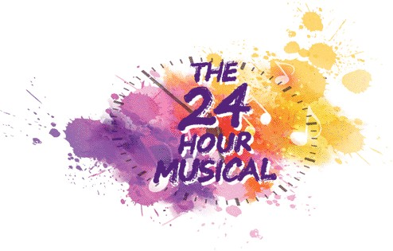
4th – 5th September 2020

Thank you for signing up to be a part of 24 Hour Musical at Camberley Theatre.
Please complete all parts of this form and attach a photograph or email a digital copy to us so that the production team can plan casting in advance.

Name of performer
Contact Email
Contact Mobile Number
Playing Age
Costume Sizes – Men | Hat Neck  Nape of neck to waist Chest  Waist Shoulder to shoulder  Leg Inside Leg  Shoe Height
Costume Sizes – Women | Hat Glove  Nape of neck to waist Chest/Bust  Waist Shoulder to shoulder  Hip Inside Leg  Shoe Height
Singing Skills – please tick | Soprano (high) Mezzo (mid) Alto (low)  Tenor (high) Baritone (mid) Bass (low)  I’m not sure what any of this means, but I’ll give it a go!
Dancing Skills – please tick | Experienced Intermediate Beginner  I’ve got two left feet! Willing to give it a go Legend at a disco!  Ballet Tap Jazz  Any other specific skills:  (gymnastics / circus skills)
What type of role are you interested in?  (Remember it’s an intense rehearsal period!) |  | Principal  (all singing, all dancing) |  | Supporting  (maybe a few lines or song)
 |  | Cameo  (featured one liner) |  | Ensemble  (I’ll join in – as long as I’m not on my own!)

Performance History  (tell us a bit about you and what performance history you have. Don’t worry if you’ve never done it before!)  Please give details of any previous shows you have performed/taken part in. | Professional Experienced  Amateur Done a bit  Complete novice Singing in the shower
Do you have a link to any online media we can watch or listen to?
What interests you about the 24 Hour Musical?
How did you hear about the 24 hour musical?

The 24 Hour Musical is pre-cast and all casting decision are made at the discretion of the production team. There is a show fee payable in advance to take part in the production and show T-shirts/Hoodies can be ordered. Details will be sent to you nearer the time.
FAQs and more info available on our website.

Please return this form by email to 24hr@creativemindsproductions.co.uk

Many thanks – we look forward to seeing you on Friday 4th September 2020 for the
5th annual 24 Hour Musical

Eddie and Polly - Team 24

