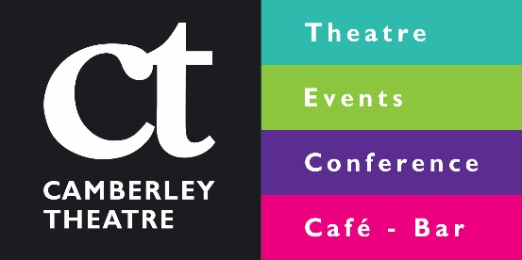
Camberley Theatre Kid’s Party Booking Form
Name
Address
Phone Number
Mobile Number
Email
Type of Party | Indoor Parties  Traditional Games Party  Neon Disco  Crazy Character Party  Theatre VIP
Date of Party
Time of Party
Number of Children
Birthday Child’s Name and Age
Specify Theme / Theatre show (optional)

All parties require a £50 non-refundable deposit to confirm the booking.
Invites are available free of charge from the Box Office.
Please be aware of the following conditions:
- Minimum of 15 children for all parties. Maximum number of children for all indoor parties is 30.
- All food except birthday cake is provided by Camberley Theatre and we do not allow self-catering.
- 2 adults must be present at all times. We request that parents who wish to stay during the activity wait in the bar at the Theatre, or the Function Room.
- You are welcome to bring decorations and party bags; please leave these with your party host on arrival.
- All cancellations must be made 14 days before the party date. Any cancellations after this date will be charged for in full unless a suitable alternative date can be arranged.
Please email this form to camberley.theatre@surreyheath.gov.uk

