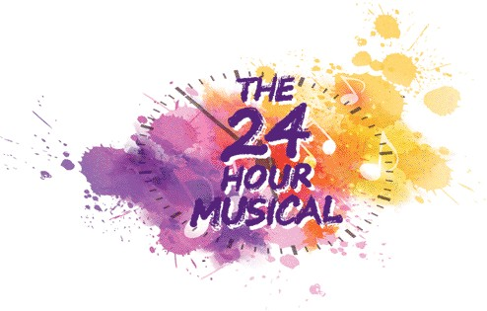
6 – 7 September 2019

Thank you for signing up to be a part of 24 Hour Musical at Camberley Theatre.
Please complete all parts of this form and attach a photograph or email a digital copy to us so that the production team can plan casting in advance.

Name of performer
Contact Email
Contact Mobile Number
Playing Age
Costume Sizes – Men | Hat Neck  Nape of neck to waist Chest  Waist Shoulder to shoulder  Leg Inside Leg  Shoe Height
Costume Sizes – Women | Hat Glove  Nape of neck to waist Chest/Bust  Waist Shoulder to shoulder  Hip Inside Leg  Shoe Height
Singing Skills – please tick | Soprano (high) Mezzo (mid) Alto (low)  Tenor (high) Baritone (mid) Bass (low)  I’m not sure what any of this means, but I’ll give it a go!
Dancing Skills – please tick | Experienced Intermediate Beginner  I’ve got two left feet! Willing to give it a go Legend at a disco!  Ballet Tap Jazz  Any other specific skills:  (gymnastics / circus skills)
What type of role are you interested in?  (Remember it’s an intense rehearsal period!) |  | Principal  (all singing, all dancing) |  | Supporting  (maybe a few lines or song)
 |  | Cameo  (featured one liner) |  | Ensemble  (I’ll join in – as long as I’m not on my own!)

Performance History  (tell us a bit about you and what performance history you have. Don’t worry if you’ve never done it before!)  Please give details of any previous shows you have performed/taken part in. | Professional Experienced  Amateur Done a bit  Complete novice Singing in the shower
Do you have a link to any online media we can watch or listen to?
What interests you about the 24 Hour Musical?
How did you hear about the 24 hour musical?

The 24 Hour Musical is pre-cast and all casting decision are made at the discretion of the production team. There is a show fee payable in advance to take part in the production and show T-shirts/Hoodies can be ordered using the attached form.
FAQs and more info available on our website.

Please return this form by email to 24hr@creativemindsproductions.co.uk

Many thanks – we look forward to seeing you on Friday 6th September,

Eddie and Polly - Team 24

24 Hour Musical 2019 Souvenir T-Shirt/Hoodie
Souvenir Clothing will be ordered in advance, at a cost of £15 (T-Shirt) / £25 (Hoodie), and we will be printing on the reverse with the names of all those involved in the production including cast, crew and production team.

…………………………………………………………………………………………………….
Please circle the size you would like:

What size T-Shirt would you like:

Adult Small Adult Medium Adult Large Adult Extra-Large

What size Hoodie would you like:

Adult Small Adult Medium Adult Large Adult Extra-Large

I have paid for my order online, with reference code CM24HR2019, to

Creative Minds

Metro Bank (Guildford) Sort Code: 23-05-80
Account Number: 13353255

I will pay on the night using card payment

(There will be a £1 sur-charge to use the card payment system)

Please return this form, with payment, to

CREATIVE MINDS 24 HOUR c/o Camberley Theatre, Knoll Road, Camberley, Surrey, GU15 3SY

